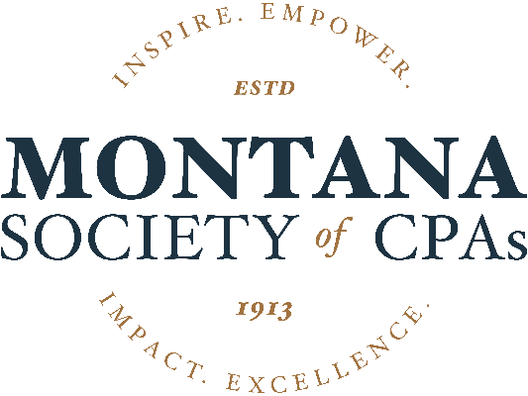
NOMINATION FORM

Please complete this nomination form and describe your nominee’s attributes and why you feel they should receive the award.
Learn about MTCPA’s awards and criteria here

Nominee’s Name Click or tap here to enter text.
Award Choose an item.

Nominated By Click or tap here to enter text.
Phone Click or tap here to enter text.
Email Click or tap here to enter text.
Would you like to remain anonymous? Yes ☐ No ☐
If anonymous, your nominee will not be told you nominated them. The MTCPA will need to know, however, in case we have any questions regarding the nomination. Your information will be kept confidential

RETURN TO:
erinn@montana.cpa OR mail to: Montana Society of CPAs │ PO Box 138 │ Helena, MT 59624

NOMINATION DEADLINE: DECEMBER 15TH

The Awards will be presented at the Annual Conference in June, except for the Outstanding CPA in Industry, which will be presented at the Industry Conference in March.

For additional information, please contact Erinn at 406-442-7301 or erinn@montana.cpa

